Data Storage in Clojure

Options, Analysis, and Assessment  
*Brian Abbott, February 20th, 2019*

Note: this document is available online at: <https://docs.google.com/document/d/11zGRKTfzAK4GT8Kv41NyQebY89zAjk4Xs9uBzc_iAQY/edit?usp=sharing>

**Revision History** **3**

**Overview** **4**

Example Application and Data Model 4

Requirements in Showcase Application and Data-model 4

Showcase Data-model 4

Our Data Story 6

Overview of our Analysis Process 8

Native Data Operations 8

Data Operations with Clojure Core APIs 9

Data Operations via Frameworks and Libraries 9

HugSQL 10

Korma 11

Honey SQL 12

SQLingvo 12

oj 13

Suricatta 13

Aggregate 14

Toucan 15

Considered but dropped 16

Yesql 16

Overview of our Data-Store Analysis Targets 16

PostgreSQL - a case for PostgreSQL 16

SQL:2011 Window Function row-visibility via the Over Clause 17

Create Procedure Support 18

Fetch-First Support 19

MongoDB 20

Datomic 20

What sorts of applications is Datomic designed for? 21

**PostgreSQL** **23**

PostgreSQL Overview 23

The PostgreSQL Datamodel 23

The PostgreSQL Native Query Language 23

Native Data Operations 23

Schema Representation Operations 23

Native Insert Operations 27

Native Update Operations 28

Native Delete Operations 28

Native Retrieval Operations 29

Clojure Data-Operation Expressions 29

Clojure Datamodel Expression 29

Clolure Insert Expression 29

Clojure Update Expression 29

Clojure Delete Expression 29

Clojure Retrieval Expression 29

**MongoDB** **30**

MongoDB Overview 30

The MongoDB Datamodel 30

The MongoDB Native Query Language 30

**Datomic** **31**

Datomic Overview 31

Product offerings and variations 31

**Clojure Data-storage Components, Frameworks and Toolkits** **32**

**Analysis** **33**

SQL vs Datalog - A 1-to-1 Compare 33

**References and Resources** **34**

Bibliographical References 34

Web Resources 34

Web Articles 34

Specific to Datomic 34

Specific to Postgres 35

Twitter 35

Video Resources 35

Specific to Datomic 36

Specific to MongoDB 38

Specific to PostgreSQL 38

Specific to Clojure 39

# Revision History

|  |  |  |
| --- | --- | --- |
| Version | Notes | Date |
| 0.1 | A Strawman Alpha | 02.15.2019 |

# 

# Overview

Falling out of the developer standup meeting on 02.15.2019 regarding our choices and, potential migration away from and too alternative persistent data storage engines now, or perhaps at various points in the future, it is valuable for us to do an extended exploratative evaluation of what a variety of data-storage options might look like for us as well as, to what degree of compatibility might we find between data-storage platforms and perhaps additionally, what frameworks, toolkits and supporting development and production applications and tool-sets might we find available for any one potential or currently selected data storage platforms.

It is also good to keep in mind, while currently we are in a position that is best and ideal for us to have only one single primary data-storage platform, considering common application-platform growth paths as well as taking into consideration the nature of Health-Care Information Systems and Processing, it is easy for one to arrive at the consideration that we are more then likely to find ourselves in a future position of needing to integrate with multiple data-platforms simultaneously and, at equal levels of integration and application supporting functionality.

## Example Application and Data Model

In order to find a basis for comparative analysis, it is ideal for us to synthesize a common application data model that we then re-render for each data-platform to which we seek to understand and then, view that data platform through the lense of the degree of complexity in rendering the application on each platform. To that end, we will capture here a simple User-Registration Application Data-Model that we will use throughout our data-platform analysis.

### Requirements in Showcase Application and Data-model

TODO: Fill me out...

### Showcase Data-model

In thinking about and trying to identify a nice example application model for our research, I came across this already developed and delivered model which was part of the template diagram from Draw.io for the Database Model Diagram. This template can be seen below and, is available in its raw web format from draw.io (<https://www.draw.io/>) by creating a new diagram and selecting the Software Template Collection and clicking on software/database_1.xml.

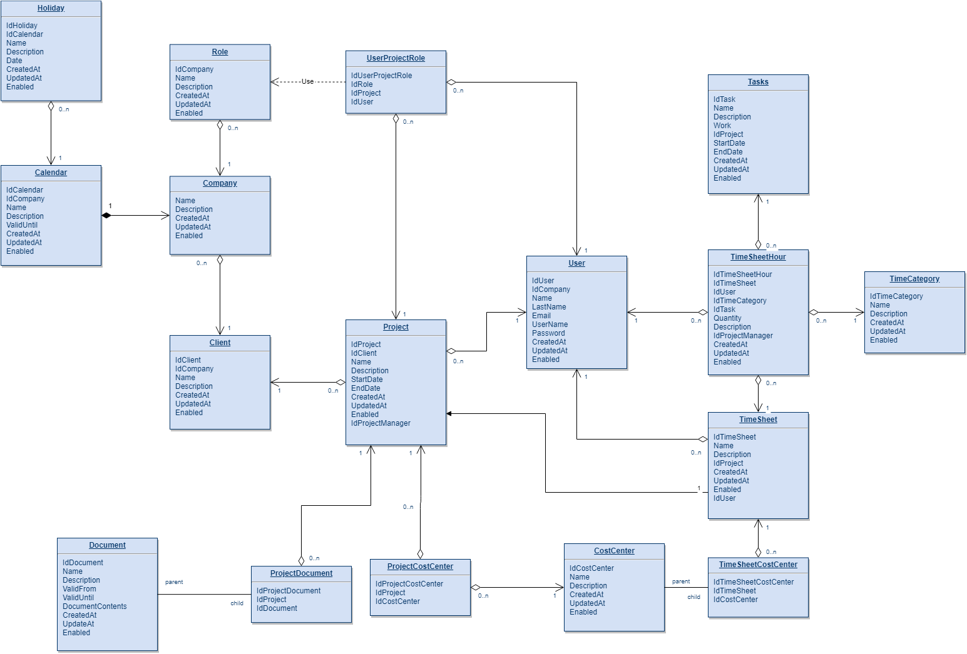

This is a data-model for project-management including cost-accounting. Now, while this is quite nice - albeit somewhat hard to see in this document - it is a bit more code then we want to type in and recreate for having a small experimental data-application. Therefore, we will focus on a simplified subset of the data-model for our purposes.

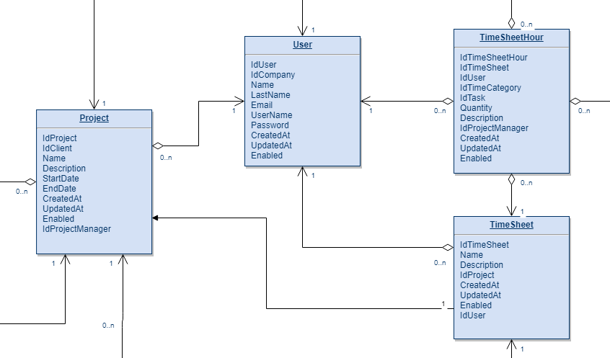

This is better. It's a subset that's highly referential, integrated, and interdependent. In simpler terms - it has the shape (I think) that we’re looking for. We can write some complex data-model requirements and corresponding queries and actions against this for the four basic CRUD operations and beyond. Let’s go with it. We will add in the primitive field-types, et al later as we get going with each data-store, as the types might change there anyway.

### Our Data Story

Now that we’ve outlined our schema, we need to come up with some data to put in it or rather, a story that will drive the data we put into it. The project management and cost-accounting application under test is for the BoingBoing^2 Aircraft Corporation, located in SeaTown USA. They design and build super secret aircraft using advanced space-jet technologies. They have to keep their teams small to manage the classified nature of their work. To that end, they employ 2 (project) managers, 4 workers, and have 16 active projects and to date have issued 256 billable timesheets for a total of 65536 time-sheet hours.

Our Project Managers are Sally and Susan, who manage four workers, Bob, Larry, Moe, Tyler who currently work on 16 projects:

* A-12 Avenger II
* AA160 Hummingbird
* Bird of Prey
* Condor
* F/A-XX Program
* Pelican
* Phantom Ray
* Quad TiltRotor (QTR)
* X-32
* X-37
* X-40
* X-45
* X-48
* X-53 Active Aeroelastic Wing
* YF-23
* ZZX-51 Waverider

Projects are split evenly between Sally and Susan in Alphabetical order except for the Avenger and Waverider projects, which they both manage together. Given all that, we have the following table that outlines our data-instance structure.

|  |  |  |  |  |
| --- | --- | --- | --- | --- |
| Project | Managed By | Worker(s) | Timesheets | Hours |
| A-12 Avenger II | Sally, Susan | Bob, Larry, Moe, Tyler | 32 |  |
| AA160 Hummingbird | Susan | Bob, Larry | 14 |  |
| Bird of Prey | Sally | Larry, Moe | 14 |  |
| Condor | Susan | Moe, Tyler | 14 |  |
| F/A-XX Program | Sally | Tyler, Bob | 14 |  |
| Pelican | Susan | Bob, Moe | 14 |  |
| Phantom Ray | Sally | Larry, Bob | 14 |  |
| Quad TiltRotor (QTR) | Susan | Moe, Larry | 14 |  |
| X-32 | Sally | Tyler, Moe | 14 |  |
| X-37 | Susan | Bob, Tyler | 14 |  |
| X-40 | Sally | Larry, Tyler | 14 |  |
| X-45 | Susan | Moe, Bob | 14 |  |
| X-48 | Sally | Tyler, Larry | 14 |  |
| X-53 Active Aeroelastic Wing | Susan | Bob, Larry | 14 |  |
| YF-23 | Sally | Larry, Moe | 14 |  |
| ZZX-51 Waverider | Sally, Susan | Bob, Larry, Moe, Tyler | 32 Timesheets |  |

## Overview of our Analysis Process

For each data storage platform, we will run, albeit somewhat mechanically, through a same series of operations as we investigate each target platform. This will produce a result that will read somewhat monotonous but, provide a strong basis for an equality of compare. The demonstrative tasks that will drive our analytical operations are as follows:

* Native Data Operations
* Data Operations with Clojure Core APIs
* Data Operations via Frameworks and Libraries

First, by data-operations, we mean Data-Model or Schema representation and augmentation operations, such as create, and modify as well as to be able to insert, update, and delete records within our schema - the common operations performed against a database. Where a given data-platform does not allow or, provides a significantly different mechanism for a common data-operation, we will highlight it and, provide an analysis of the reason for the difference as well as to describe and illustrate the alternative operations native to the given platform.

### Native Data Operations

By native, we mean to utilize and demonstrate operations in the raw language syntax of each data-platform. Additionally, in these exercises, we desire to have an affinity for methods that are the most germain or resident to the target platform over those that are generic or common. While we may or may not want to interact with our data-store platforms this way in production, we are motivated in these analytical exercises to come to an understanding of the platform that minimizes the distance from the platforms most intrinsic and raw ways, methods, tastes and preferences for doing things while maximizing our distance from any one of the many given standards for data-storage, data-querying, and data-retrieval of which, there are many (i.e. SQL, RDF/SPARQL, XML) - it is not our goal to know common intersections but, to establish an intimate familiarity with each platform. An example of this might be, while Postgres might support standard SQL, we seek to understand the internal operations of the engine, as well as the enhancements and nuances made available to us by the Postgres native PG-SQL Query Language.

### Data Operations with Clojure Core APIs

The data operations captured and discussed within these sections will be either with the clojure java.jdbc API or, with the native libraries that each corresponding platform either provides, points-to, or sanctions as, “the clojure way of connecting to and operating upon this data engine”. For example, while MongoDB does not itself provide a Clojure API, Monger from November-Rain (<http://clojuremongodb.info/>) is the community accepted library to connect to and operate on a MongoDB instance from within Clojure.

### Data Operations via Frameworks and Libraries

This list and, this aspect of our endeavour is meant to be somewhat exhaustive. The reasoning and motivation for this is that, these components, if adopted, will become the intermediary between our application code and our datastore. Depending on the provided model of interaction, the code utilizing and dependant upon these libraries could become quite ubiquitous and pervasive throughout our codebase and, therefore, it could became both a costly as well as a high-risk if not impossible endeavour to transition from one library to another, perhaps even more difficult and concerning then it might be to move from one data storage platform to another. Therefore, we want to ensure that the SQL/Data Querying framework(s) that we select, provide a maximum adaptability between a variety of Data Storage Engines.

The instance I reflect on when coming to this conclusion is the LINQ technology incorporated within the .NET Framework. LINQ makes it exceedingly easy to directly code, from anywhere within your application code, at anytime, against your database, as if you are simply calling functions against object instances. This generally means that, once you adopt LINQ and the Entity Framework within your .NET project, data-access-layer client code, directly hitting the primary storage engine, quickly ends up all over your application and is virtually impossible to remove in larger production codebases without either taking an inordinate amount of time or, inducing a choking degree of risk within your release to remove. Therefore, I feel that it is worth the while and the effort to fully explore and exhaust our options in this regard, as many of these frameworks appear to be quite powerful and capable and, therefore, deserve a degree of analysis and understanding that is on par with their capability. -*”With great power, comes great responsibility”* and, therefore it is on us to know the extent and limitations of these frameworks and then, with that knowledge to choose one or orchestrate multiple and unleash that power unto and within the heart of our core frameworks. To that end, the list of frameworks that we shall seek to understand and capture their interaction with each of our data-storage engines is as follows.

* HugSQL
* Korma
* Honey SQL
* SQLingvo
* oj
* Suricatta
* aggregate
* Toucan

The following frameworks were considered but dropped upon further investigation. The reasoning behind their exclusion will be described within their respectives sections.

* Yesql

NOTE: TODO: Rather then including this analysis action within each target, we might include it outside individual data-platforms at the end in a consolidated compare and contrast, if it becomes too repetitive or verbose for the desired density and length of the document (something to be read and understood in a single 30 minute reading). This decision will be made as we go about understanding and illustrating the first couple data-store engines.

#### HugSQL

The name Hug means to embrace SQL, effectively giving it a Hug. This is befitting as it captures the central philosophy behind Hug. Hug also seems to be widely referenced and adopted however, it also appears to be the least interesting in that it is primarily mappings from SQL files to Clojure Functions through a three step coding process. First, we define a SQL file with mapping definitions captured as SQL comments.

|  |
| --- |
| -- :name create-characters-table -- :command :execute -- :result :raw -- :doc Create characters table -- auto_increment and current_timestamp are -- H2 Database specific (adjust to your DB) **create** **table** **characters** (  **id** integer auto_increment primary **key**,  **name** varchar(40),  specialty varchar(40),  created_at **timestamp** **not** **null** **default** **current_timestamp** ) |

Then we call Hug to read our data definitions, causing functions to be created for us that are a product derived from the mapping definitions supplied in the SQL files.

|  |
| --- |
| (**ns** db.characters  (:require [hugsql.core :as hugsql]))  (**hugsql/def-db-fns** "db/sql/characters.sql") (**hugsql/def-sqlvec-fns** "db/sql/characters.sql") |

And finally, we call database functions from within our application code that produce SQL statements available for execution through and active database connection.

|  |
| --- |
| (**characters/characters-by-ids-specify-cols-sqlvec**  {:ids [1 2], :cols ["name" "specialty"]})  ;;=> ["select name, specialty from characters  where id in (?,?)",1,2] |

One benefit of Hug is its huge and well maintained library of developer documentation, available at: <https://www.hugsql.org/>. The codebase for HugSQL can be found at: <https://github.com/layerware/hugsql>.

#### Korma

Korma is perhaps the oldest, and certainly most popular SQL DSL for Clojure. It uses a  
macro-based DSL to represent queries as if they were Clojure forms:

|  |
| --- |
| (**defentity** users)  (**select** users  (**where** {:active **true**})  (**order** :created)  (**limit** 5)  (**offset** 3)) |

Korma is designed to replace java.jdbc for all data-store operations. It provides a comprehensive API for declaring database relationships and properties, and you’ll probably never need to drop into SQL unless you want to use some database-specific features. That said, you can still use the sql-only macro to retrieve a SQL vector from Korma to do with what you will. Another positive attribute of Korma is its extensive documentation available at <http://sqlkorma.com/>. The codebase for Korma can be found at: <https://github.com/korma/Korma>

#### Honey SQL

HoneySQL represents queries as a map, which you can then format into an SQL string for use with data.jdbc:

|  |
| --- |
| (**h/format** {:select [:*]  :from [:users]  :where [:= :active **true**]  :order-by [:created]  :limit 5  :offset 3}) |

It also provides helper functions for building said map. Each function works like an assoc, so you can pipe them together, which ends up looking very korma-y

|  |
| --- |
| (**->** (**select** :*)  (**from** :users)  (**where** := :active **true**)  (**order-by** :created)  (**limit** 5)  (**offset** 3)  (**h/format**)) |

Both of those produce a vector containing an SQL string and any bound parameters, which you can plug (in this case) directly into java.jdbc‘s query function to get a result back. HoneySQL can be found here: <https://github.com/jkk/honeysql>.

#### SQLingvo

SQLLingvo works a lot like HoneySQL, but defines a slightly different-looking DSL and eschews the intermediary maps (actually, it does use maps if you try executing the functions alone, but they’re a lot less readable than HoneySQL’s). Instead, the base query functions (select etc.) can contain forms modifying the query, and it applies the transformations internally rather than externally as in honey.

|  |
| --- |
| (**select** db [*]  (**from** :users)  (**where** '(**=** :active **true**))  (**order-by** :created)  (**limit** 5)  (**offset** 3)) |

In the code above, the db argument is defined by a call to sqlingvo.db.postgresql, which you might expect means a query is executed - This is not the case! The db argument is there to tell sqlingvo how to quote the query, which could be a nice feature if you use a particularly uptight database. The function above produces a SQL vector for use with query just as in the honeysql examples. SQLLingvo can be found here: <https://github.com/r0man/sqlingvo>

#### oj

oj (all lowercase) is similar to HoneySQL, representing queries as Clojure maps. The biggest difference is that oj provides a facility (exec) for executing the maps directly, rather than rendering them as strings and passing them to jdbc:

|  |
| --- |
| (**oj/exec** {:table :users  :where {:active **true**}  :order-by :created  :limit 5  :offset 3} db-spec) |

Like honeysql, oj also provides utilities for not using a map. However, they’re so basic that reading their implementation feels [almost sarcastic](https://github.com/taylorlapeyre/oj/blob/master/src/oj/modifiers.clj). I tried to render the above example, but offset is not present (and if it was, it would just be #(assoc %1 :offset %2)). OJ is primarily about using maps to express SQL operations. At the outset, this feels very much like the HTML libraries provided by Luminus. oj can be found here: <https://github.com/taylorlapeyre/oj>

#### Suricatta

Suricatta is a combination jdbc helper (providing some nice refinements over jdbc’s api) and Korma-esque query DSL. Here’s what the latter looks like:

|  |
| --- |
| (**->** (**d/select** :email)  (**d/from** :users)  (**d/where** ["active = ?" **true**])  (**d/order-by** :created)  (**d/limit** 5)  (**d/offset** 3)  (**sqlvec**)) ; => ["select email from users where (active = ?) order by created asc limit ? offset ?" true 5 3] |

Suricatta can be found here: <https://github.com/funcool/suricatta>

#### Aggregate

Aggregate is interesting in that it builds from concepts specified in the widely acclaimed book “Domain Driven Design” by Eric Evans. Aggregate provides three core database operation functions and then takes sets of definitions in order to execute the functions. From Martin Fowler on the DDD Aggregate Pattern: *“Aggregate is a pattern in Domain-Driven Design. A DDD aggregate is a cluster of domain objects that can be treated as a single unit. An example may be an order and its line-items, these will be separate objects, but it's useful to treat the order (together with its line items) as a single aggregate.”*

|  |
| --- |
| (**ns** agg-app  (:require [aggregate.core :as agg]))   (**agg/load** er-config db-spec entity-keyword id) (**agg/save!** er-config db-spec data) (**agg/delete!** er-config db-spec data) |

Saving a project-definition in aggregate looks like this.

|  |
| --- |
| (**def** project (**agg/save!** er @h2/db-con :project  {:name "Learning Clojure"  :customer {:name "Big Company"}  :tasks [{:desc "Buy a good book" :effort 1}  {:desc "Install Java" :effort 2}  {:desc "Configure Emacs" :effort 4}]  :members [{:name "Daisy"}  {:name "Mini"}]  :manager {:name "Daisy"}})) |

aggregate can be found here: <https://github.com/friemen/aggregate>.

#### Toucan

Toucan builds on HoneySQL to incorporate design ideas from Korma while providing an ORM-esque experience in Clojure. Toucan provides the better parts of an ORM for Clojure, such as simple DB queries, flexible custom behavior when inserting or retrieving objects, and easy hydration of related objects. Toucan builds on top of clojure.java.jdbc and HoneySQL. The primary motivation behind Toucan was to bring some of the missed conveniences of Korma over to HoneySQL. The Toucans ORM-like behavior can be demonstrated in this sample.

|  |
| --- |
| ;; define the User model (**defmodel** User :user  IModel  (**types** [this]  {:status :keyword}))  ;; Insert a new User (**db/insert!** User :name "Cam", :status :new)  ;; Fetch User 200 (**User** 200) |

The only requirement to making code like this work is to first define a JDBC connection to the data store engine.

|  |
| --- |
| (**require** '[toucan.db :as db])  (**db/set-default-db-connection!**  {:classname "org.postgresql.Driver"  :subprotocol "postgresql"  :subname "//localhost:5432/my_db"  :user "cam"}) |

Toucan can be found here: <https://github.com/metabase/toucan>

#### Considered but dropped

##### Yesql

Yesql was considered for evaluation as it was quite frequently mentioned on the web however, upon investigation, I found that the github landing page had the following text in the readme and, therefore I am taking it out as a contender for our purposes.

*“Status: Frozen. Maintainer sought.*

*Tested with Clojure 1.5-1.9-alpha20, but there will be no new development unless a maintainer steps up.*

*...*

*(You might also consider hugsql which is philosophically similar and actively maintained.)”*

## Overview of our Data-Store Analysis Targets

Everything up to this point has setup for us a general framework for data-platform analysis, from which we can add or remove any given data-platform, now or at any point in the future. To some extent, that is a core goal of this document, to outline and prescribe for us a core framework that can be utilized at any point in time to rapidly understand how a considered data platform or data-framework API will interact and integrate with our platform and with the clojure programming language.

TODO: Include requirements/criteria for inclusion…

Criteria for inclusion:

* Popularity
* Compatibility with Clojure

At the time of this initial writing, we seek to understand through our analysis process, the following data-storage platforms:

* PostgreSQL
* MongoDB
* Datomic

### PostgreSQL - a case for PostgreSQL

One of our top, key targets for understanding is the PostgreSQL Open Source Relational Engine. Postgres is a highly utilized, well know, well supported and highly capable relational engine.

This chart, provided by the db-engines.com ranking engine, which utilizes a custom application specific search engine to identify database popularity, clearly shows Postgres holding strong as the number four most utilized database in the world.

|  |  |  |  |  |  |  |  |
| --- | --- | --- | --- | --- | --- | --- | --- |
| **Rank** | | | **DBMS** | **Database Model** | **Score** | | |
| **Feb**  **‘19** | **Jan**  **‘19** | **Feb**  **‘18** | **Feb**  **19** | **Jan**  **19** | **Feb**  **18** |
| 1. | 1. | 1. | [Oracle](https://db-engines.com/en/system/Oracle) | Relational, Multi-model | 1264 | -4.82 | -39.26 |
| 2. | 2. | 2. | [MySQL](https://db-engines.com/en/system/MySQL) | Relational, Multi-model | 1167 | +13 | -85.18 |
| 3. | 3. | 3. | [Microsoft SQL Server](https://db-engines.com/en/system/Microsoft+SQL+Server) | Relational, Multi-model | 1040 | -0.21 | -81.98 |
| 4. | 4. | 4. | [PostgreSQL](https://db-engines.com/en/system/PostgreSQL) | Relational, Multi-model | 473 | +7.45 | +85.18 |
| 5. | 5. | 5. | [MongoDB](https://db-engines.com/en/system/MongoDB) | Document | 395 | +7.91 | +58.67 |
| 6. | 6. | 6. | [IBM Db2](https://db-engines.com/en/system/IBM+Db2) | Relational, Multi-model | 179 | -0.43 | -10.55 |
| 7. | 7. | up arrow 8. | [Redis](https://db-engines.com/en/system/Redis) | Key-value, Multi-model | 149 | +0.43 | +22.43 |
| 8. | 8. | up arrow 9. | [Elasticsearch](https://db-engines.com/en/system/Elasticsearch) | Search, Multi-model | 145 | +1.81 | +19.93 |
| 9. | 9. | down arrow 7. | [Microsoft Access](https://db-engines.com/en/system/Microsoft+Access) | Relational | 144 | +2.41 | +13.95 |
| 10. | 10. | up arrow11. | [SQLite](https://db-engines.com/en/system/SQLite) | Relational | 126.17 | -0.63 | +8.8 |

In addition to being quite popular as a data storage platform, Postgres is one of the more feature rich, capable databases. While we discussed earlier the desire to capture resident or intrinsic behaviors over industry standard ones, one strong highlight of Postgres is its full and early on support for new SQL standards. We will spend some time here highlighting some of the functionality-comparison charts that highlight the breadth and depth of Postgres supported standard SQL functionality over its competitors.

#### SQL:2011 Window Function row-visibility via the Over Clause

Window Functions were originally standardized in SQL:2003 and n the SQL:2011 Standard, support was introduced for what is referred to as the Over Clause. An over clause selects or sets which rows or, distances from a given row are available to a Window Function. As we can see from the support matrix below, PostgreSQL version 11, the most recent version, by far exceeds support beyond any other traditional relational database engine.

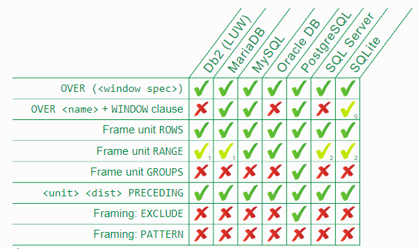

#### Create Procedure Support

Create Procedure support was only added in Postgres 11 (although User Functions - what we normally think of for PG-SQL have been there forever) however, while being a late comer to the game, Postgres, aside from the corporate backed DB2, currently boasts the greatest degree of support for the Create Procedure and associated syntactical artifacts.

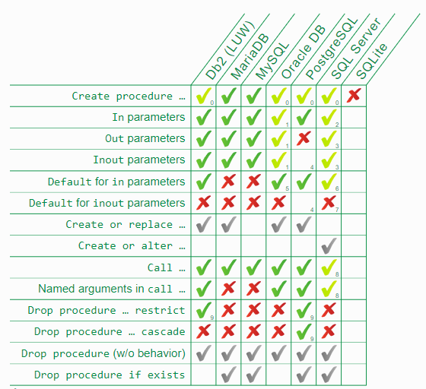

Note that, the empty box marked with a number 4 in subscript, on the line titled “Inout parameters”, was unavailable to be tested as the JDBC driver utilized currently does not support the functionality.

#### Fetch-First Support

Again, like the two previous feature-matrices, the only databases to outperform Postgres are expensive proprietary systems with massive corporate backing. In this chart, we can see that, other then Oracle, Postgres offers the most extensive and complete support of the SQL-Standard Fetch First N syntax, the non-proprietary variance to the limit clause.

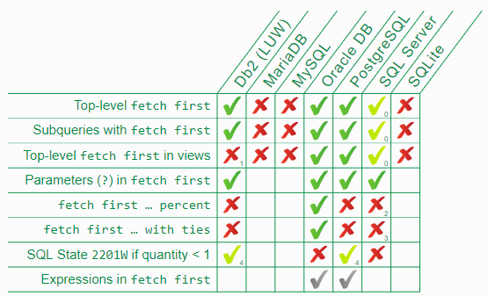

We will go into more details regarding Postgres in the dedicated section however, these details offer just a glimpse as to the strength and viability offered by Postgres. In the realm of traditional Relational, RDBMS platforms, Postgres is quite clearly a leading contender.

### MongoDB

A case for MongoDB - NOTE: We may not include this platform in our studies.

### Datomic

TODO: This section needs to be cleaned up and is not finished - I am trying to find better, more appropriate use, presentation and comparative resources that I can utilize to build an objective (i.e. first-eyes) case for Datomic (by first eyes, I mean - to present these cases for each platform as if the reader has never seen or heard of it, at least relative to the other platforms - these sections are meant to read like short brochures).

A case for Datomic

This database platform, more than any other, has the total and absolute backing of the Clojure Community - this is the clojure database.

Now, being the

Aside from being THE Clojure Database, created and sanctioned by the creator of Clojure, Datomic genuinely does have a very unique and novel data-model. Because of this core model, Datomic enables the handling of row-oriented, column-oriented, graph, and hierarchical data within a single system. Additionally, Datomic is natively or intrinsically time-aware.

Datomic has three product variants, which means, for the purposes of our analysis, we have to somewhat pick one and run with it. For this, we will select Datomic Cloud. The reasoning is that, first, we have already started a transition to Datomic Cloud, it very much makes the most sense.

As stated by Cognitect, the features of Datomic Cloud are as follows:

* Indelibility and Auditability
* Flexible Data Model
* ACID Transactions
* Powerful Query Language
* Horizontal Read Scaling

In addition to those core engine capabilities, Datomic’s close integration with AWS enables offloading of administrative tasks and, perhaps most importantly of operating and scaling burdens, removing common operational chores such as hardware provisioning, setup and configuration, as well as capacity planning. While it is true that other database platforms will run on AWS within EC2 containers and, Amazon has built their own data-platform offerings through the RDS organization, is is nice to see a third party data-platform work to integrate as deeply with AWS as Amazon’s own data platforms do.

### What sorts of applications is Datomic designed for?

Datomic is designed as a general-purpose fully ACID transactional data of record system. It is a good fit for systems that store valuable information of record, require developer and operational flexibility, need history and audit capabilities, and require read scalability. Some examples of successful Datomic use cases include transactional data, business records, medical records, financial records, scientific records, inventory, configuration, web applications, departmental databases, and cloud applications.

# 

# PostgreSQL

## PostgreSQL Overview

### The PostgreSQL Datamodel

### The PostgreSQL Native Query Language

PostgreSQL Toolsets, Applications, and Production Support, etc.

## Native Data Operations

### Schema Representation Operations

The following set of pg-sql commands create our schema within our PostgreSQL instance.

Our first operation is to create what we will call the database or schema, which we will call for the Postgres exercise, “nomihealth-datastore-pgsql”. We can create the database with the following PG-SQL code.

|  |
| --- |
| -- Database: nomihealth-datastore-ana  -- DROP DATABASE "nomihealth-datastore-pgsql";  **CREATE** **DATABASE** "nomihealth-datastore-pgsql"  **WITH**   OWNER = postgres  **ENCODING** = 'UTF8'  LC_COLLATE = 'English_United States.1252'  LC_CTYPE = 'English_United States.1252'  **TABLESPACE** = pg_default  **CONNECTION** **LIMIT** = -1; |

Now that we have our database, we want to begin creating our tables. The first table that we will create is the Project Table. The project table is defined by the following PG-SQL code.

|  |
| --- |
| **CREATE** **TABLE** public."Project" (  "IdProject" integer **NOT** **NULL**,  "Name" text **NOT** **NULL**,  "Description" text,  "StartDate" date,  "EndDate" date,  "CreatedAt" abstime,  "UpdatedAt" abstime,  "Enabled" boolean,  "IdProjectManager" integer **NOT** **NULL**,  PRIMARY **KEY** ("IdProject") ) **WITH** (  OIDS = **FALSE** );  **ALTER** **TABLE** public."Project"  OWNER **to** postgres; |

Now we will create our User table, which, in reality, we should have done first since the Project table has a foreign key constraint on its IdProjectManager column to a User row. But, that is okay, we want to see what happens when we mess up and, how easy is it to resolve by adding only the fragment of our necessary update later on. We will make the same mistake with the other databases as we move through them. Here is the SQL required to create our User table.

|  |
| --- |
| **CREATE** **TABLE** public."User" (  "IdUser" integer **NOT** **NULL**,  "IdCompany" integer,  "Name" text **NOT** **NULL**,  "LastName" text **NOT** **NULL**,  "Email" text **NOT** **NULL**,  "UserName" text **NOT** **NULL**,  "Password" text **NOT** **NULL**,  "CreatedAt" abstime **NOT** **NULL**,  "UpdatedAt" abstime **NOT** **NULL**,  "Enabled" boolean **NOT** **NULL**,  **CONSTRAINT** "user-id" PRIMARY **KEY** ("IdUser") ) **WITH** (  OIDS = **FALSE** );  **ALTER** **TABLE** public."User"  OWNER **to** postgres; |

Create TimeSheet Table

|  |
| --- |
| **CREATE** **TABLE** public."TimeSheet" (  "IdTimeSheet" integer **NOT** **NULL**,  "Name" text **NOT** **NULL**,  "Description" text,  "IdProject" integer **NOT** **NULL**,  "CreatedAt" abstime,  "UpdatedAt" abstime,  "Enabled" boolean,  "IdUser" integer,  **CONSTRAINT** "timesheet-id" PRIMARY **KEY** ("IdTimeSheet"),  **CONSTRAINT** "fk-project" FOREIGN **KEY** ("IdProject")  **REFERENCES** public."Project" ("IdProject") **MATCH** SIMPLE  **ON** **UPDATE** **NO** **ACTION**  **ON** **DELETE** **NO** **ACTION**  **NOT** VALID,  **CONSTRAINT** "fk-user" FOREIGN **KEY** ("IdUser")  **REFERENCES** public."User" ("IdUser") **MATCH** SIMPLE  **ON** **UPDATE** **NO** **ACTION**  **ON** **DELETE** **NO** **ACTION** ) **WITH** (  OIDS = **FALSE** );  **ALTER** **TABLE** public."TimeSheet"  OWNER **to** postgres; |

Create TimeSheetHour Table

|  |
| --- |
| **CREATE** **TABLE** public."TimeSheetHour" (  "IdTimeSheetHour" integer **NOT** **NULL**,  "IdTimeSheet" integer **NOT** **NULL**,  "IdUser" integer **NOT** **NULL**,  "IdTimeCategory" integer,  "IdTask" integer,  "Quantity" numeric,  "Description" text,  "IdProjectManager" integer **NOT** **NULL**,  "CreatedAt" abstime,  "UpdatedAt" abstime,  "Enabled" boolean,  **CONSTRAINT** "timeSheetHour-id" PRIMARY **KEY** ("IdTimeSheetHour"),  **CONSTRAINT** "fk-timesheet" FOREIGN **KEY** ("IdTimeSheet")  **REFERENCES** public."TimeSheet" ("IdTimeSheet") **MATCH** SIMPLE  **ON** **UPDATE** **NO** **ACTION**  **ON** **DELETE** **NO** **ACTION**,  **CONSTRAINT** "fk-user" FOREIGN **KEY** ("IdUser")  **REFERENCES** public."User" ("IdUser") **MATCH** SIMPLE  **ON** **UPDATE** **NO** **ACTION**  **ON** **DELETE** **NO** **ACTION**,  **CONSTRAINT** "fk-projectManager" FOREIGN **KEY** ("IdProjectManager")  **REFERENCES** public."User" ("IdUser") **MATCH** SIMPLE  **ON** **UPDATE** **NO** **ACTION**  **ON** **DELETE** **NO** **ACTION** ) **WITH** (  OIDS = **FALSE** );  **ALTER** **TABLE** public."TimeSheetHour"  OWNER **to** postgres; |

And, that does it! We have our database and, four tables. Now what would be nice would be to point a live ERD tool at our Postgres instance and verify that it looks like our originally specified diagram. To Be Continued for now.

Oh, whoops, we forgot to go back and add our constraint that we had forgotten in the first table operation. We need a Foreign Key Constraint from Project to User on the IdProjectManager field, let's do that now and see how hard it is to make the update!

|  |
| --- |
| **ALTER** **TABLE** public."Project"  **ADD** **CONSTRAINT** "fk-projectManager" FOREIGN **KEY** ("IdProjectManager")  **REFERENCES** public."User" ("IdUser") **MATCH** SIMPLE  **ON** **UPDATE** **NO** **ACTION**  **ON** **DELETE** **NO** **ACTION**; **CREATE** **INDEX** "fki_fk-projectManager"  **ON** public."Project"("IdProjectManager"); |

Not too bad! That updates (via an Alter Table statement) the Project table to capture a foreign-key constraint on the User table, in order to ensure that every projects Project-Manager field points to an active and real user.

We finally have our complete and total schema definition, expressed, as PG-SQL statements. Now we are ready to go and create some data via PG-SQL INSERT operations.

### 

### Native Insert Operations

#### First a Test Insert

First we will need to create our Users, as we learned in the previous exercise with our Schema, that table is the root of our hierarchy however before we begin inserting the users we that we outlined in our Data-Story section, lets first create a test user, which we will then delete, just to make sure we know what we are doing and, that our table structure and field definitions were created and set-up correctly.

|  |
| --- |
| **INSERT** **INTO** public."User"(  "Name", "LastName", "Email", "UserName", "Password", "CreatedAt",  "UpdatedAt", "Enabled") **VALUES** ('test.name', 'test.lastName', 'test.email',  'test.userName', 'test.password', **now**(), **now**(), **true**); |

And … Wham! We get an error once we execute that script

|  |
| --- |
| postgres-# ERROR: **null** **value** **in** **column** "**IdUser**" **violates** **not**-**null** **constraint** **DETAIL**: **Failing** **row** **contains** (**null**, **null**, **test.name**, **test.lastName**, **test.email**, **test.userName**, **test.password**, 2019-02-19 05:09:12-08, 2019-02-19 05:09:12-08, **t**). **SQL** **state**: 23502 |

From this, we can see that we did something wrong in the setup of our original schema. It appears that the Primary-Key constraint for the IdUser column is not being activated on INSERT operations and creating an auto-generated, unique, primary key value as we expected by the original table definition.

Lets resolve that, not only for User but, for all of our tables. To do this, we will need to drop our foreign key constraints, alter the Id<TableName> fields, and then re-apply the foreign key constraints.

As it turns out, the correct syntax for creating our Primary Key constraints is as follows:

|  |
| --- |
| **CREATE** **TABLE** TableName (  Id<TableName> serial primary **key**,  ...  ) |

Now that we know that, lets just drop our Foreign Key constraints and recreate our tables with the correct syntax for the Primary Key definitions. First, we’ll drop our Foreign Keys.

|  |
| --- |
| **ALTER** **TABLE** public."Project" **DROP** **CONSTRAINT** "fk-user";  **ALTER** **TABLE** public."TimeSheet" **DROP** **CONSTRAINT** "fk-project";  **ALTER** **TABLE** public."TimeSheet" **DROP** **CONSTRAINT** "fk-user";  **ALTER** **TABLE** public."TimeSheetHour" **DROP** **CONSTRAINT** "fk-projectManager";  **ALTER** **TABLE** public."TimeSheetHour" **DROP** **CONSTRAINT** "fk-timesheet";  **ALTER** **TABLE** public."TimeSheetHour" **DROP** **CONSTRAINT** "fk-user"; |

Now, we just to to re-execute our table create scripts with the Primary Key’s defined as constraints removed and, to modify the column definitions of the Id<Table> columns as we re-execute our create scripts. The Primary Key Constraint Definition appears as follows:

|  |
| --- |
| CONSTRAINT "timeSheetHour-id" PRIMARY KEY ("IdTimeSheetHour"), |

Once we re-run our create scripts, lets also re-run the test SQL INSERT script:

|  |
| --- |
| **INSERT** **INTO** public."User"(  "Name", "LastName", "Email", "UserName", "Password", "CreatedAt",  "UpdatedAt", "Enabled") **VALUES** ('test.name', 'test.lastName', 'test.email',  'test.userName', 'test.password', **now**(), **now**(), **true**); |

We now receive the following output on our console:

|  |
| --- |
| INSERT 0 1  Query returned successfully **in** 73 msec. |

Perfect, now we now that at least our User’s table definition is operational as we had originally expected it to be. Lets execute a test query to ensure that our primary-key values are also coming back as expected.

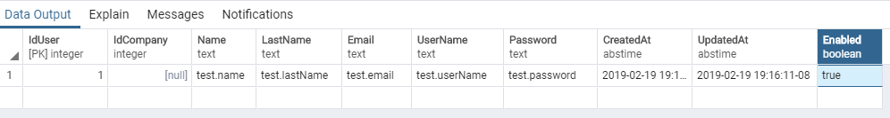

Excellent, the primary key value came back as 1 without us manually inserting it, as we were originally looking for. Now we can go on to our INSERT operations.

#### User Table Inserts

We have 6 users as we outlined in our Data Story section: Sally, Susan, Bob, Larry, Moe, Tyler. This script will create row-entries for each user.

|  |
| --- |
| -- Create script for: Sally, Susan, Bob, Larry, Moe, Tyler  -- Sally Sallus, ssallus@boingboing.com **INSERT** **INTO** public."User"(  "Name", "LastName", "Email", "UserName",  "Password", "CreatedAt", "UpdatedAt", "Enabled") **VALUES** (  'Sally', 'Sallus', 'ssallus@boingboing.com',  'ssallus', 'pa55word', **now**(), **now**(), **true**);  -- Susan Susus, ssusus@boingboing.com **INSERT** **INTO** public."User"(  "Name", "LastName", "Email", "UserName",  "Password", "CreatedAt", "UpdatedAt", "Enabled") **VALUES** (  'Susan', 'Susus', 'ssusus@boingboing.com',  'ssusus', 'pa55word', **now**(), **now**(), **true**);  -- Bob Bobus, bbobus@boingboing.com **INSERT** **INTO** public."User"(  "Name", "LastName", "Email", "UserName",  "Password", "CreatedAt", "UpdatedAt", "Enabled") **VALUES** (  'Bob', 'Bobus', 'bbobus@boingboing.com',  'bbobus', 'pa55word', **now**(), **now**(), **true**);  -- Larry, Larus, llarus@boingboing.com **INSERT** **INTO** public."User"(  "Name", "LastName", "Email", "UserName",  "Password", "CreatedAt", "UpdatedAt", "Enabled") **VALUES** (  'Larry', 'Larus', 'llarus@boingboing.com',  'llarus', 'pa55word', **now**(), **now**(), **true**);  -- Moe, Moeus, mmoeus@boingboing.com **INSERT** **INTO** public."User"(  "Name", "LastName", "Email", "UserName",  "Password", "CreatedAt", "UpdatedAt", "Enabled") **VALUES** (  'Moe', 'Moeus', 'mmoeus@boingboing.com',  'mmoeus', 'pa55word', **now**(), **now**(), **true**);  -- Tyler, Tylus, ttylus@boingboing.com, pa55word,  **INSERT** **INTO** public."User"(  "Name", "LastName", "Email", "UserName",  "Password", "CreatedAt", "UpdatedAt", "Enabled") **VALUES** ('Tyler', 'Tylus', 'ttylus@boingboing.com',  'ttylus', 'pa55word', **now**(), **now**(), **true**); |

Now, let’s verify that our users were all correctly created with another SELECT * operation.

### 

Excellent, our users are all there just as we expected! Except, we now have one issue that, we need (or, should) delete our test user so, let’s do that now.

|  |
| --- |
| -- DELETE FROM public."User" -- SELECT * from public."User" WHERE "IdUser" = 1; **DELETE** **from** public."User" **WHERE** "IdUser" = 1; -- SELECT * from public."User" WHERE "IdUser" = 1; |

Executing this script should produce the following results.

|  |
| --- |
| DELETE 1  Query returned successfully **in** 168 msec. |

Within the delete script, there are two SQL scripts captured in the comments that can be used to determine first that the entry exists, so that we know that the WHERE clause in our delete is correct and, then it can be ran again to verify that the entry no longer exists by running it and seeing that it returns no results. If our SQL skills where a bit more advanced, we could use the SELECT to drive the input to the DELETE operation’s WHERE clause, a technique that we can utilize later on when we begin doing more complex operations in PGSQL. Now, let’s do the same things for the rest of our data instance items.

### Native Update Operations

### Native Delete Operations

### Native Retrieval Operations

## Clojure Data-Operation Expressions

### Clojure Datamodel Expression

### Clolure Insert Expression

### Clojure Update Expression

### Clojure Delete Expression

### Clojure Retrieval Expression

# 

# MongoDB

TODO: We might not do or consider this one… we’ll see… Hold tight Mongo! :)

## MongoDB Overview

### The MongoDB Datamodel

### The MongoDB Native Query Language

# 

# Datomic

## Datomic Overview

### Product offerings and variations

# 

# Clojure Data-storage Components, Frameworks and Toolkits

TODO: This is where the libs (i.e hugsql, korma) will go...

# 

# Analysis

TOSAY: Everything has been building up to this - the reason and purpose for thie document, these exercises, everything prior - the moment we’ve all been waiting for! :)

Assessments on a standalone basis….

## SQL vs Datalog - A 1-to-1 Compare

TODO: directly compare SQL syntax against Datomic Datalog

# 

# References and Resources

## Bibliographical References

TODO: Include RDF Standard here

TODO: Include SPARQL References

TODO:

TODO: Include SQL Bibliographies

[SQL-86](https://en.wikipedia.org/w/index.php?title=SQL-86&action=edit&redlink=1) (or SQL-87) is the *ISO 9075:1987* standard of 1987

[SQL-89](https://en.wikipedia.org/w/index.php?title=SQL-89&action=edit&redlink=1) is the *ISO/IEC 9075:1989* standard of 1989

[SQL-92](https://en.wikipedia.org/wiki/SQL-92) is the *ISO/IEC 9075:1992* standard of 1992

[SQL:1999](https://en.wikipedia.org/wiki/SQL:1999) is the *ISO/IEC 9075:1999* standard of 1999

[SQL:2003](https://en.wikipedia.org/wiki/SQL:2003) is the *ISO/IEC 9075:2003* standard of 2003

[SQL:2006](https://en.wikipedia.org/wiki/SQL:2006) is the *ISO/IEC 9075:2006* standard of 2006

[SQL:2008](https://en.wikipedia.org/wiki/SQL:2008) is the *ISO/IEC 9075:2008* standard of 2008

[SQL:2011](https://en.wikipedia.org/wiki/SQL:2011) is the *ISO/IEC 9075:2011* standard of 2011

[SQL:2016](https://en.wikipedia.org/wiki/SQL:2016) is the *ISO/IEC 9075:2016* standard of 2016

## 

## Web Resources

### Web Articles

#### Specific to Datomic

Dustin's Datomic FAQ

<http://www.dustingetz.com/:datomic-faq>

#### Specific to Postgres

Jonathan Katz: WITH Queries: Present & Future

<https://info.crunchydata.com/blog/with-queries-present-future-common-table-expressions>

Bruce Momjian: Imperative to Declarative to Imperative

Baron Schwartz: Citus: Scale-Out Clustering and Sharding for PostgreSQL

Markus Winand: PostgreSQL 11 Reestablishes Window Functions Leadership

Jobin Augustine: plprofiler – Getting a Handy Tool for Profiling Your PL/pgSQL Code

Joe Conway: PostgreSQL Deep Dive: How Your Data Model Affects Storage

Bruce Momjian: Composite Values

### Twitter

[**@**datomic_team](https://twitter.com/datomic_team)

[**@**cognitect](https://twitter.com/cognitect)

[**@**clojure_conj](https://twitter.com/clojure_conj)

[**@**puredanger](https://twitter.com/puredanger)

[**@**CursiveIDE](https://twitter.com/CursiveIDE)

[**@**stuarthalloway](https://twitter.com/stuarthalloway)

[**@**ClojureWerkz](https://twitter.com/ClojureWerkz)

## Video Resources

### Specific to Datomic

Rich Hickey on Datomic Ions, September 12, 2018  
<https://www.youtube.com/watch?v=thpzXjmYyGk>

Length: 1:45:49

Notes/Thoughts:

KotlinConf 2018 - Datomic: The Most Innovative DB You've Never Heard Of

<https://www.youtube.com/watch?v=hicQvxdKvnc>

Length: 39:45

Notes/Thoughts:

Reactive Datalog for Datomic - Nikolas Göbel

<https://www.youtube.com/watch?v=ZgqFlowyfTA>

Length: 31:36

Notes/Thoughts:

Day of Datomic Cloud - Session 1

<https://www.youtube.com/watch?v=yWdfhQ4_Yfw>

Length: 41:28

Notes/Thoughts:

Rich Hickey: Deconstructing the Database

<https://www.youtube.com/watch?v=Cym4TZwTCNU>

Length: 1:06:23

Notes/Thoughts:

Datomic by Rich Hickey

<https://www.youtube.com/watch?v=4iaIwiemqfo>

Length: 1:30:55

Notes/Thoughts:

I put 7 years of meal data in Datomic - Here's what I learned - Christian Johansen

<https://www.youtube.com/watch?v=ORQ2qs8GHsQ>

49:27

Length:

Notes/Thoughts:

Intro to Datomic

<https://www.youtube.com/watch?v=RKcqYZZ9RDY>

Length:

Notes/Thoughts:

YOW! 2016 Stuart Sierra - Building Flexible Systems with Clojure and Datomic

<https://www.youtube.com/watch?v=5YGcHIwDRao>

Length:

Notes/Thoughts:

Lucas Cavalcanti & Edward Wible - Exploring four hidden superpowers of Datomic

<https://www.youtube.com/watch?v=7lm3K8zVOdY>

Length:

Notes/Thoughts:

Architecting a Modern Financial Institution

<https://www.youtube.com/watch?v=VYuToviSx5Q>

Length:

Notes/Thoughts:

Datomic: up and running

<https://www.youtube.com/watch?v=ao7xEwCjrWQ>

Length:

Notes/Thoughts:

Simplifying ETL with Clojure and Datomic - Stuart Halloway

<https://www.youtube.com/watch?v=oOON--g1PyU>

Length:

Notes/Thoughts:

David Greenberg - Building Interactive Query Tools on Datomic

<https://www.youtube.com/watch?v=YHctJMUG8bI>

Length:

Notes/Thoughts:

"Immutable Data Science with Datomic, Spark and Kafka" by Konrad Scorciapino and Mauro Lopes

<https://www.youtube.com/watch?v=VexLSuOvb0w>

Length:

Notes/Thoughts:

Lessons from 4 Years with Datomic w/ Robert Stuttaford

<https://www.youtube.com/watch?v=35z96UzUCpg>

Length:

Notes/Thoughts:

Day of Datomic Cloud - Session 2

<https://www.youtube.com/watch?v=ZP-E2IgqKfA>

Length:

Notes/Thoughts:

Datomic Made Easy Datomic in the Cloud - Stuart Halloway

<https://www.youtube.com/watch?v=Ljvhjei3tWU>

Length:

Notes/Thoughts:

WormBase database migration to Datomic on AWS: A case Study - Adam Wright

<https://www.youtube.com/watch?v=RzE9iencxT0>

Length:

Notes/Thoughts:

PolyConf 16: Datomic in production, 1 year in / Hans Hübner

<https://www.youtube.com/watch?v=0y6QK813new>

Length:

Notes/Thoughts:

Working with Datomic

<https://www.youtube.com/watch?v=kd1yTmx7m2A>

Length:

Notes/Thoughts:

Serverless-ish: Zero to App with Datomic Cloud and GraphQL - Chris Johnson Bidler

<https://www.youtube.com/watch?v=SUfgKiTI8nE>

Length:

Notes/Thoughts:

### Specific to MongoDB

### Specific to PostgreSQL

### 

### 

### Specific to Clojure

TODO: remove this section

The Language of the System - Rich Hickey

<https://www.youtube.com/watch?v=ROor6_NGIWU>

Expert to Expert: Rich Hickey and Brian Beckman - Inside Clojure

<https://www.youtube.com/watch?v=wASCH_gPnDw>

Length:

Notes/Thoughts: